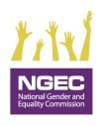

REPORTING TOOL ON GENDER MAINSTREAMING IN THE GOVERNMENT OF KENYA, 2022/2023
Public Sector Quarterly Gender Mainstreaming Reporting Tool FY 2022/23
QUARTER: …………………………………………………………………………………
Full Name of the Ministry, Department, Agency or County: …………………………………………………………………………………
- Type of Institution(Tick where applicable)
- Ministry/State Department  - State Corporation  - Public University |  |  |  | - Tertiary Institution  - Semi-Autonomous Govt Agency  - County Government  - Others(specify)__________
B. Indicators
- Were gender mainstreaming activities included in the annual work plan? |  |  |  |  |  |  |  |  | [Yes] [No]
2. a) What is the total amount of the MDA's 2022/23 annual budget.  b) What amount was allocated for Gender Mainstreaming and GBV Prevention and Response in the Financial Year 2022/2023. |  |  |  |  |  |  |  |  | Total budget:  Kshs………………….  Budget for Gender mainstreaming and GBV programming: Kshs.…………………
- Does the MDA have a Gender Policy aligned to the National Policy on Gender and Development, 2019? |  |  |  |  |  |  |  |  | Yes [ ]  No [ ]  (Attach evidence)
4. Did the MDA implement the Gender Mainstreaming Policy in (3) above? |  |  |  |  |  |  |  |  | [Yes]  [No]  If yes, indicate the actions and attach evidence
 | Indicators |  |  |  | Sex |  | Persons With Disabilities |  | Minorities &  Marginalized  Communities |  | Age Category
 |  |  |  |  | F | M | F | M | F | M | Below 35 |  | 35 & above | Total
 | i. Total number of staff in MDA
 | ii. Number of employees in job group “P” and above or its equivalent
 | iii. Number of board members or its equivalent
 | iv. Number of recruited officers in the reporting period including interns and attachées
 | v. Number of officers promoted in the reporting period
5. Does the MDA have a workplace Policy on Gender Based Violence (GBV) in line with the relevant national policies and laws? (Tick as appropriate) |  |  |  |  |  |  |  |  | [Yes]  [No]  (Attach evidence)
6. Did the MDA implement the workplace Policy on Gender Based Violence in (5) above? |  |  |  |  |  |  |  |  | [Yes]  [No]  If yes, indicate the actions and attach evidence
7. Did the MDA implement relevant laws on prevention and response to GBV? The Laws include but not limited to: The Constitution of Kenya (2010), Sexual Offences Act, 2006, Children Act, 2001, Public Officers Ethics Act, 2003, Employment Act, 2007. |  |  |  |  |  |  |  |  | [Yes]  [No]  If yes, indicate the actions and attach evidence.
 | C. Please give a brief account of how your institution has integrated gender perspectives into it’s programmes, activities and projects including formulation of sector specific frameworks for Gender Mainstreaming. (Attach evidence). …………………………………………………………………………………………………………………………………………………………………………………
 | - Please highlight any emerging issues or challenges faced in the process of mainstreaming gender and integrating gender equality in your institution -------------------------------------------------------------------------------------------------------------------------------------------------------------------------------------------------------------------------------------------------------------------------------------------------------------------------------------------------------------------------------------------------------------------------
- Submit to the State Department for Gender on Email: pcontracting5@gmail.com and a copy to the National Gender and Equality Commission: Email: pcontracting@ngeckenya.org

NB: This reporting tool should be signed and stamped by the Accounting Officer; and submitted not later than 5th of the month following the end of the quarter. Only a digital copy will be accepted

- Name of Accounting Officer:…………………………………………………………. Signature:……………………………….. Date……………………………..
 | Name of Reporting Officer | Designation | Telephone Number |  |  |  |  | Email Address |  |  |  | Date
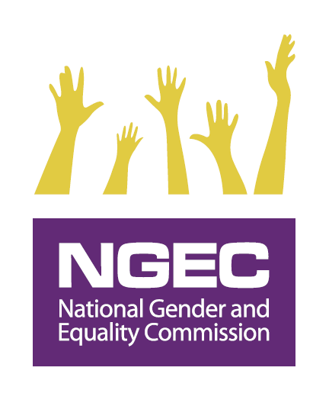
MEASURING PERFORMANCE ON THE GENDER MAINSTREAMING INDICATOR: 2022/2023 PC
Indicator in PC Guidelines | Indicator No. as per Reporting Tool | Variables in the Reporting Template | Weight/Score
- Were gender mainstreaming activities included in the annual work plan? | Institutional work plan with GBV and gender mainstreaming actions/activities included | Work plan | 2% Score
- What amount was allocated for Gender Mainstreaming and GBV Prevention and Response in the Financial Year 2022/ 2023. | Amount allocated for Gender Mainstreaming and GBV response and prevention in the financial year as per the work plan? | Resources | (5% Score)
3. a) Develop/ review and implement work place gender policy | a) Developed/Reviewed/have Gender Mainstreaming Policy (10% Score) and  b) implementation of a Gender Mainstreaming Policy (15% Score) (total 25% Score) | - Policy  - Activities derived from the policies | (25% Score)
4. Disaggregation of data on all employees as guided in the reporting tool checking on the two-thirds gender principle, disability mainstreaming & general inclusivity (5% Score). | Disaggregated data | - 2/3 Gender Principle  - 5% PWDs employed | (5% Score)
5. Develop/Review and implement the workplace Gender Based Violence policy | Developed/Reviewed/have Workplace Policy on Gender Based Violence (10% Score) and implementation of the GBV Policy (15% Score) (total 25% Score) | - Policies  - Activities derived from the policies | (25% Score)
6. Implement relevant laws on prevention and response to Gender Based Violence | Laws implemented | - Laws  - Policies  Administrative regulations | (30% Score)
7. Submit quarterly reports using the prescribed format to the State Department for Gender with a copy to National Gender and Equality Commission | Submission of the quarterly report using the reporting template as provided and observing deadlines (8 % Score)  Reporting late will lead to loss of the scores | - Submission timelines  - Correct reporting format | (8% Score)
Total Score |  |  | 100%

For more information about the policy visit http://psyg.go.ke/wp-content/uploads/2019/12/NATIONAL-POLICY-ON-GENDER-AND-DEVELOPMENT.pdf

